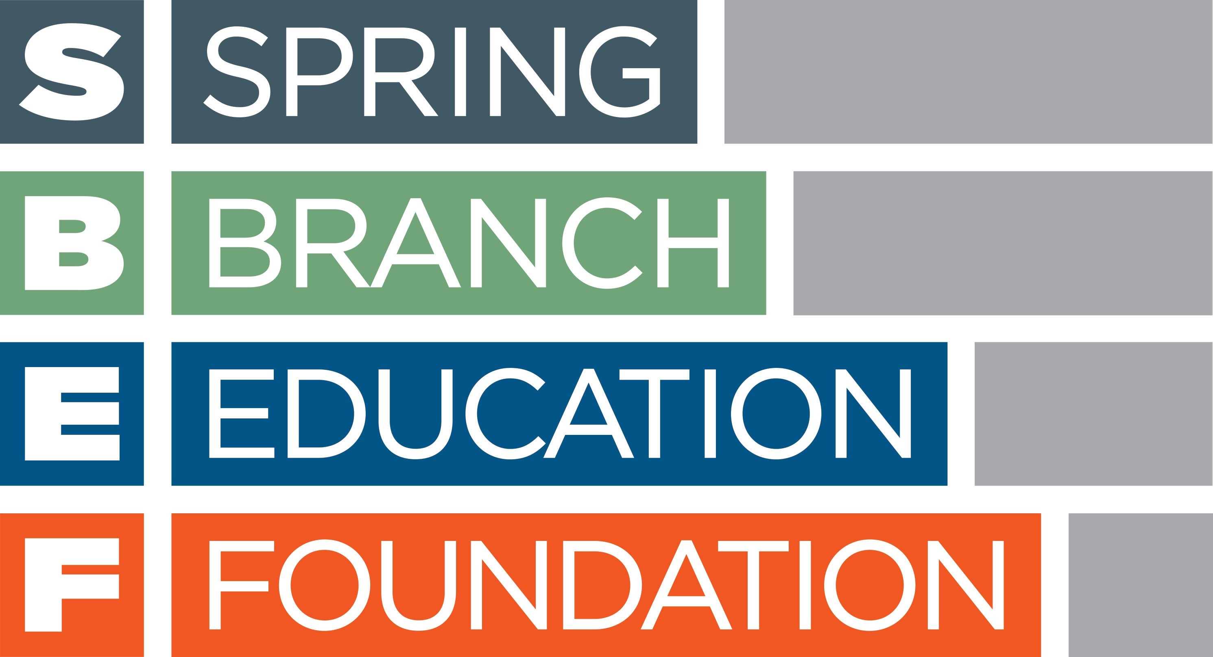

HONOR YOUR GRADUATE
BY DONATING TO SPRING BRANCH EDUCATION FOUNDATION'S

FUND FOR THE FUTURE ENDOWMENT: LEGACY 2018

- 5th Grade
- 8th Grade
- 12th Grade
Because of your participation in the Fund for the Future Endowment, all SBISD students, regardless of economic, social, or cultural circumstances, will continue to have an unlimited opportunity for an outstanding education in order to pursue their dreams. Our community, our state, and our country will reap untold benefits from your support for decades to come. This is our legacy.

Tradition Level: $25 - $99
- Student recognized in the Spring Branch Education Foundation's Annual Report

Heritage Level: $100 - $499
- Student recognized in the Spring Branch Education Foundation's Annual Report
- Student recognized on the Spring Branch ISD website

Legacy Level: $500 and above
- Student recognized in the Spring Branch Education Foundation's Annual Report
- Student recognized on the Spring Branch ISD website
- Student's name etched on a recognition plaque displayed at the student's school

Deadline for print recognition is April 13, 2018

Go online to https://sbef.ejoinme.org/legacycampaign or complete and return this form to SBEF.

PLEASE PRINT
Parent/Guardian/Donor Name: ___________________________________________________________
Home mailing address: __________________________________________________________________
Parent/Guardian email: _________________________________________________________________
Student’s Name: _______________________________________________________________________
Student’s Grade: _________________ School name: _______________________________
Level: _________________________ Amount: _____________________
( ) I am the parent or legal guardian of the above-named graduating student. I consent to the use of his/her name in any Spring Branch Education Foundation announcements, advertising or promotional material.
(Please duplicate this form for multiple graduating children.)

THANK YOU FOR YOUR DONATION TO FUND FOR THE FUTURE!
Please return this form and your check to: Spring Branch Education Foundation, 955 Campbell Road, Houston, Texas 77024. Deadline for print recognition is April 13, 2018. 713-251-2381

